The Great Famine
How did it begin?

How did the Great Famine begin?
The great Famine began in 1845, also known as ‘ The Great Hunger’.
The cause of the famine was a potato fungus called blight.
Blight came from Canada and turned all potatoes black from 1845 to 1849.
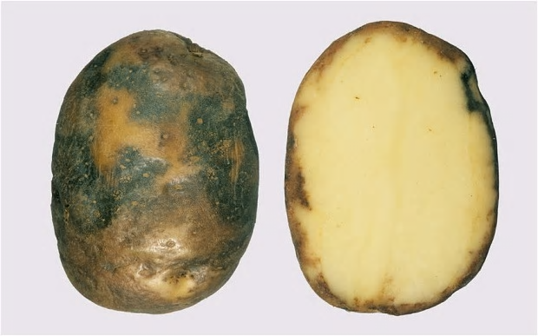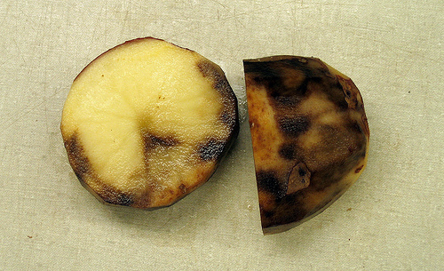

Why was the potato so important to Ireland?

The potato gained importance as a crop in Ireland in the period running up to the famine. Farmer’s found that potatoes could grow double the food on the same land. The potato was the main source of food for most people in Ireland. Certain grains such as oats and wheat were grown, but were exported by the government as were cattle and pork.

Population

During the famine, approximately 1 million people died and another million emigrated from Ireland, causing the island’s population to fall by around 20%.
After the famine the population of Ireland declined further as emigration continued and the birth rate fell. By the 1911 census, the island’s population had fallen to 4.4
million

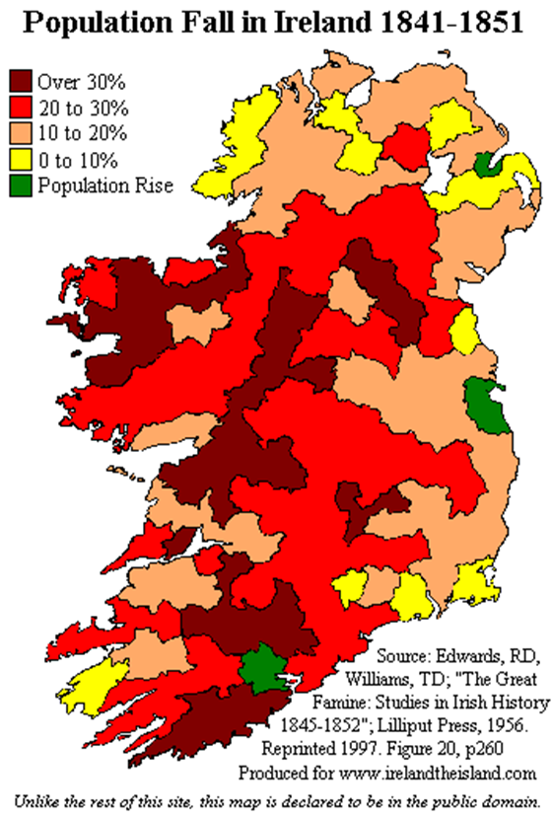

Coffin Ships

During the Great Famine of Ireland in the mid-19th century, tens of thousands of starving Irish families fled the country and emigrated to Canada and the United States. Most of the ships that sailed during the famine years were overcrowded and poorly built and had a horrible reputation of unseaworthiness.

Of the 100,000 Irish that sailed to British North America in 1847, an estimated one out of five died from disease and malnutrition, including over five thousand at Grosse Isle Quebec, Canada.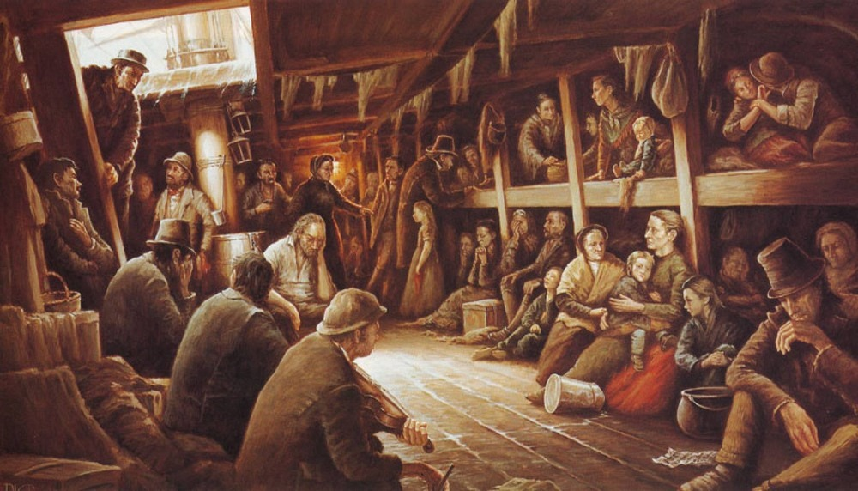

When it ended

Many of the people had also eaten their seed potatoes, therefore having no potatoes for the next year. well, The world slowly became aware of the plight of the Irish people. The British government's suggested that the problem was in Ireland and should be left to sort out or let it run its course despite the fact that other crops continued to be produced and exported while the people were dying.
To make matters even worse, some landlords began to evict those tenants who could not pay their rent, sending them wandering aimlessly from town to town in the search of food.

The Quakers, set up soup kitchens in order to try to save the population. Another attempt by the government to get the most out of the already starving and disease ridden Irish was to establish Work houses for the starving.

In Ireland, several museums have been built in order to commemorate this tragic period of Irish history. The first official one was the Famine Museum situated in Strokestown, County Roscommon, which was opened by then President Mary Robinson.

https://brilliantmaps.com/potato-famine/
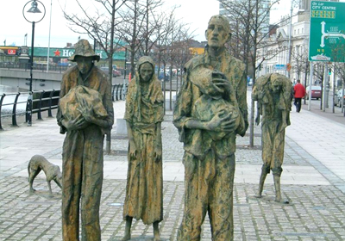
https://www.discoveringireland.com/

