Shane Lowry
Born
Born in the Midlands Regional Hospital, Mullingar, County Westmeath, Lowry, grew up in Clara, County Offaly. He is the son of Offaly’s 1982 All-Ireland winning footballer Brendan Lowry.
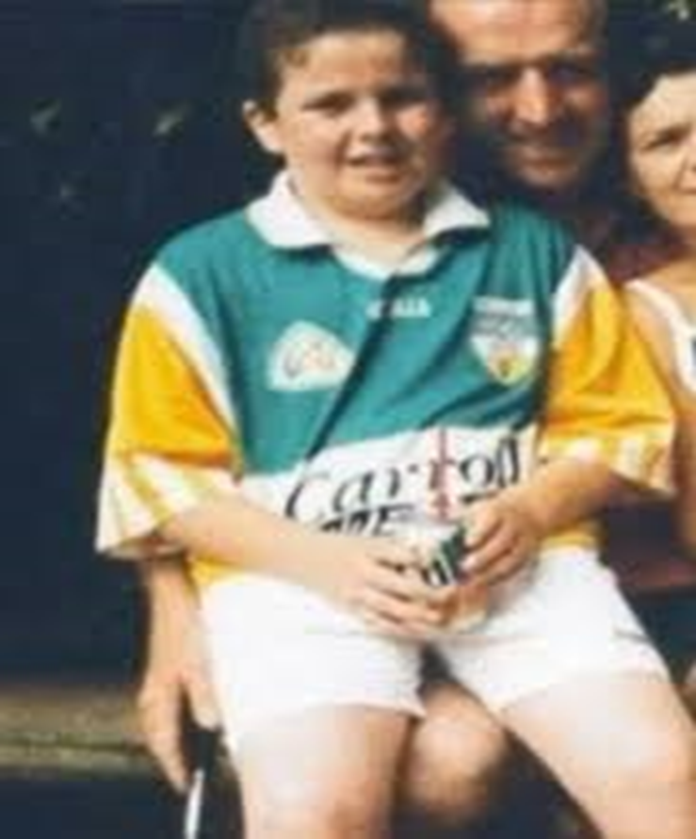

Education
He attended Athlone Institute of Technology as a scholarship student on the Higher Certificate in Sport and Recreation.

Golf career
Amateur
Lowry learned his early golf at Esker Hills Golf Club, where he began his amateur career. Lowry was the 2007 Irish Amateur Close Champion, defeating Niall Turner 4 & 3 in the final.
As an amateur in May 2009, he won The Irish Open on the European Tour, defeating Robert Rock on the third hole of a sudden death playoff. The win, on his tour début, made him just the third amateur to win on the European Tour, following Danny Lee earlier in the 2009 season, and Pablo Martín in 2007. Lowry shot a 62 to equal the lowest ever by an amateur on the circuit and led from the second round onwards.
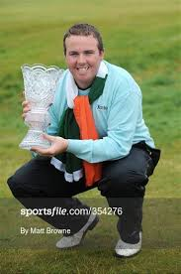

As a result, he entered the Official World Golf Ranking as an amateur at No. 168 and reached a career high of sixth in the World Amateur Golf Ranking. The win was only the second home victory since 1982 and the first since Pádraig Harrington in 2007.
Professional
Lowry elected to turn professional the week after his Irish Open win. He made his professional début on 28 May at the European Open.
Lowry missed the first three cuts of his professional career, but had his first payday on 5 July, when he finished 50th at the Open de France ALSTOM. He had his best professional result in November 2009, when he finished 3rd in the Dunlop Phoenix Tournament in Japan.
In January 2010, Lowry finished in fourth place in the Abu Dhabi Golf Championship, moving him into the top-100 of the Official World Golf Ranking.
In June 2010, Lowry qualified for his first major championship, the Open Championship at St Andrews. During the qualification, Lowry equalled Nick Faldo's course record at Sunningdale when he posted a 62. Lowry went on to make the cut at St Andrews and eventually finished in a tie for 37th place.
Lowry won for the first time as a professional in 2012, at the Portugal Masters in October. He shot a 67 to tie for the lead with the Englishman Ross Fisher, who made bogey on the final hole after missing a four-foot putt. The victory lifted Lowry back into the Official World Golf Ranking top 100 and made him eligible to compete in the WGC-HSBC Champions
In 2014, Lowry was runner-up at the BMW PGA Championship in May and later tied for ninth at the Open Championship at Royal Liverpool (Hoylake), his best finish at a major.
In August 2015, Lowry won the WGC-Bridgestone Invitational in the United States at Firestone in Akron, Ohio, two strokes ahead of runner-up Bubba Watson. Lowry accepted PGA Tour membership for the 2015–16 season.
At the 2016 U.S. Open at Oakmont Country Club near Pittsburgh. He finished the tournament tied for second place, with a final round score of 76.
Lowry did not win on the European Tour from 2016 to 2018 but was joint runner-up in the 2017 DP World Tour Championship, Dubai and runner-up in the 2018 Andalucía Valderrama Masters.
In January 2019 he won the Abu Dhabi HSBC Championship.
Lowry started the 2018-19 season with partial status after finishing 140th in the FedEx Cup. At the 2019 Open Championship at Royal Portrush, He won the tournament by six shots ahead of Tommy Fleetwood.
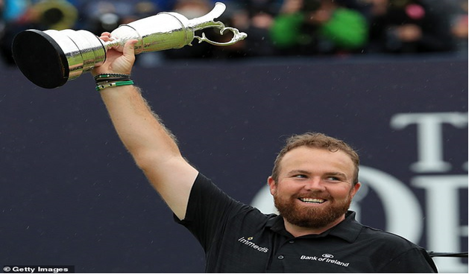

Personal life
Shane married Wendy Honner in 2016 and has one daughter, Iris, born in March 2017.
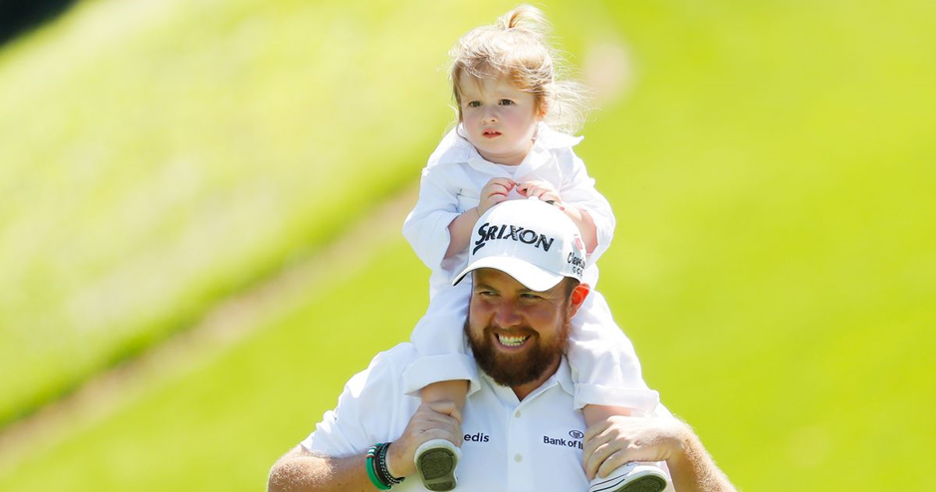

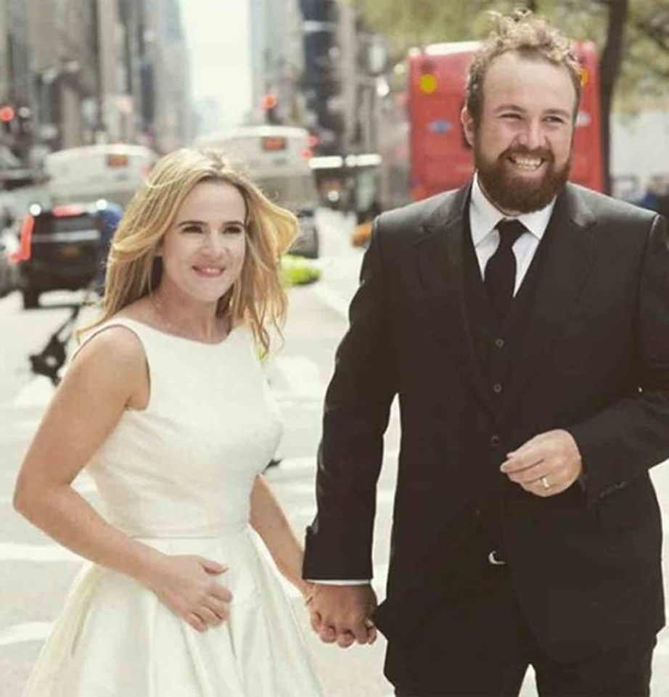

World Ranks
Date | Tournament | Position
March 12-15 | THE PLAYERS Championship | T98
Feb 27-1 | The Honda Classic | T21
Feb 20-23 | WGC-Mexico | T29
Oct 31-3 | WGC-HSBC Champ | T43
Oct 24-28 | The ZOZO Championship | T13

PGA Championship: 2019
PGA Tour: 2
Masters Tournament: 2016
Professional wins: 5

